**Lab Prep 3**

|  |  |
| --- | --- |
| Student Name | Lillian Nose |

**1. What are the technologies for measuring location especially indoors? There are including UWB, GPS, Wi-Fi, Beacons, RFID, NFC and more. Do research on these and compare among those. (5 pts)**

Technologies for measuring location indoors would include Beacons that utilize Bluetooth or (BLEs). These beacons are inexpensive and small and have a long battery life while the use of an external energy source is unnecessary, it works by detecting the signal of the device and then estimating the location from the distance. Wi-fi beacons operate similarly in the fact that it uses the distance of signals to find locations; however, they require an external power source but has a stronger signal that can have a larger range. Near Field Communication technology do not require a power source however a device can only detect the chips if it is within 30 cm of it. NFC technology is used primarily in newer phones and with sales. Ultra-Wideband (UWB) consists of placing anchors in the corners of a space with a small range and then attach a locator tag to the object of interest that is tracked every 50ms, making this the most precise method. GPS is not as effective for indoor tracking as it is limited by roofs walls and other objects. Another alternative is Passive Radio Frequency Identification tags (RFIDS) that does not necessarily help with providing detailed location information within the room but rather the object that enters a room as one example of this could be using a card to enter a room.

**2. Review** [**the basics of Gimbal**](https://support.gimbal.com/hc/en-us/articles/360015812771-Location-Platform-Overview-Video) **and explore more on Gimbal and Beacon technology. Describe what Gimbal/Beacon technology can do for Art and Museum, and also brainstorm your own research idea for PVC. (5 pts)**

Gimbal/Beacon technology could allow for museums to improve on their guided tours to be more personalized for users to choose their own path that the tour could adapt to. It could also help users to understand where they are in the museum and how far a certain painting is from them with directions, this would be especially helpful for the Phillips collection as the paintings are circulated so often. Improved directions indoors could be immensely helped with beacon technology as the layout is unique and therefore difficult to navigate.

**3. Referring to the Lab 3 manual. 1) do activate beacon in your account, 2) create, assign and apply your own name of configuration to your Beacon, and 3) Assign User-Provided Location to your Beacon. 4) Create 3 different types of places.**

**Submit “Beacon-YourLastName_YourFirstName.csv” and “Places- YourLastName_YourFirstName.csv” after export them on Gimbal Manager. (10 pts)**

|  |  |  |  |
| --- | --- | --- | --- |
| Places | Place Name | Geofence | Beacons |
| No 1 | YourLastName_YourBeaconName |  | Your Beacon |
| No 2 | YourLastName_AVW | AVW Building either with minimum radial or exact boundary with polygonal |  |
| No 3 | YourLastName_YourBeaconName_AVW | AVW Building either with minimum radial or exact boundary with polygonal | Your Beacon |

### ***\*\* Please make sure to remove the beacon from your list once you’re done with it at the end of the day, so that others can use it! (This is very important!!!)***

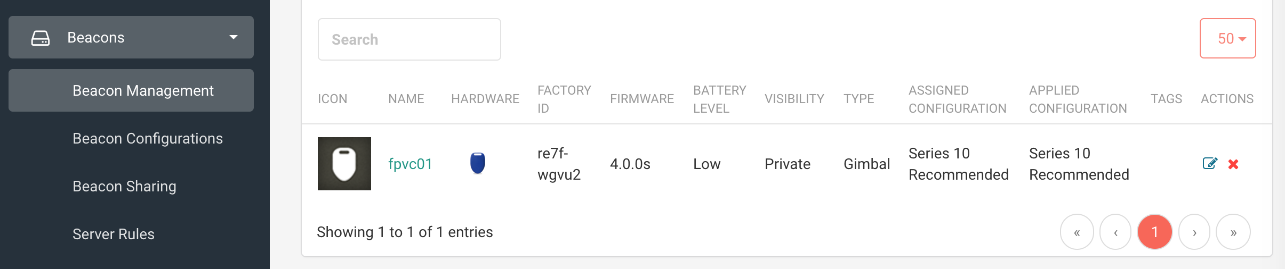

**4. Study Gimbal Places and Beacon Configurations. 1) Describe three types of Gimbal Places in your own understanding and your own words. 2) Explore Beacon Configurations and report what you’ve studied and found such as configuration type (explain those types), transmission power, antenna type, transmission interval, transmit frequency, measured power, UID/EID frame, telemetry frame. Feel free to the app “**[**Hello Gimbal**](https://support.gimbal.com/hc/en-us/articles/360004025472-Get-Started-with-the-Hello-Gimbal-App)**” either in iOS or in Android to investigate your studies above. (10 pts)**

The three types of Gimbal Places are with a single geofence that either has a set radius or a customized polygonal shape. A user is considered to enter whenever they enter within the boundaries and exits when it leaves the boundaries. The second type is one created with beacon, the difference is that a user enters when it enters the boundaries one beacon, it only exits if it exits all beacons (if there are multiple). The last type is a combination of geofences and beacons. If a user either enters the proximity of a beacon or enters the geofence, they are considered in the place. If the user leaves the geofence and all of the beacons, they are considered to be exited. With configuration types, the greater the transmission power, the larger range and stronger signal; however, it comes with a larger energy drain which could lead to a shorter batter life. Antenna types vary between omnidirectional and directional. Directional antennas are focused narrow beams that have better performance and reduced interference than their counterpart, omnidirectional antennas. Omnidirectional antennas radiate equal radio power in all directions perpendicular to an axis, it is used often for cellphones and radio broadcasting. For transmission intervals and transmit frequency these are the duration of a transmission on the radio link and how often a signal is being sent respectively. The measured power is different from the transmission power in the sense that it declares to receiving devices what the power should be at a distance of 1 meter from the beacon. The UID/EID and the telemetry frames are open beacon formats that can be another customized type of beacon.

### ***\*\* Please make sure to remove the beacon from your list once you’re done with it at the end of the day, so that others can use it! (This is very important!!!)***

